**ROLDA, Christine Mae B. Rolda**

BSIT-2 (BLOCK B)

**ACTIVITY: DATA TYPES**

* **Source Code (student_profile.html):**

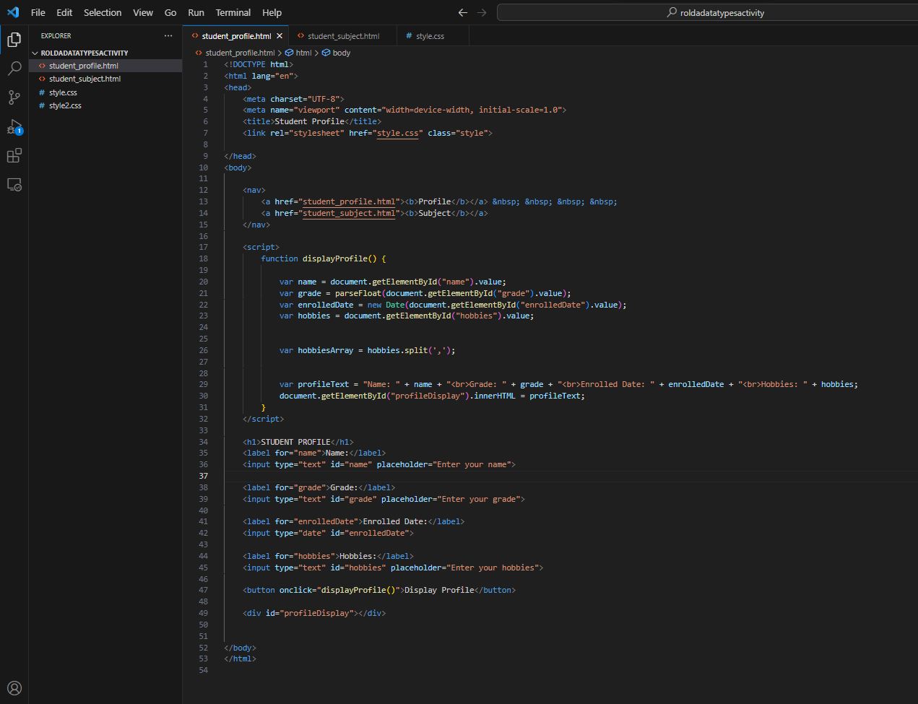

* **Source Code (student_subject.html):**

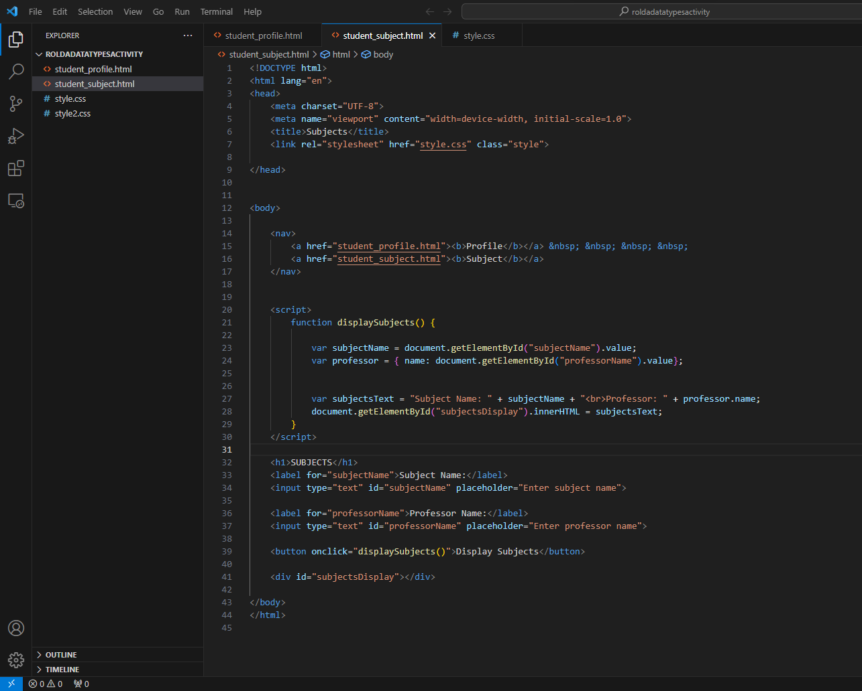

* **Source Code (style.css):**

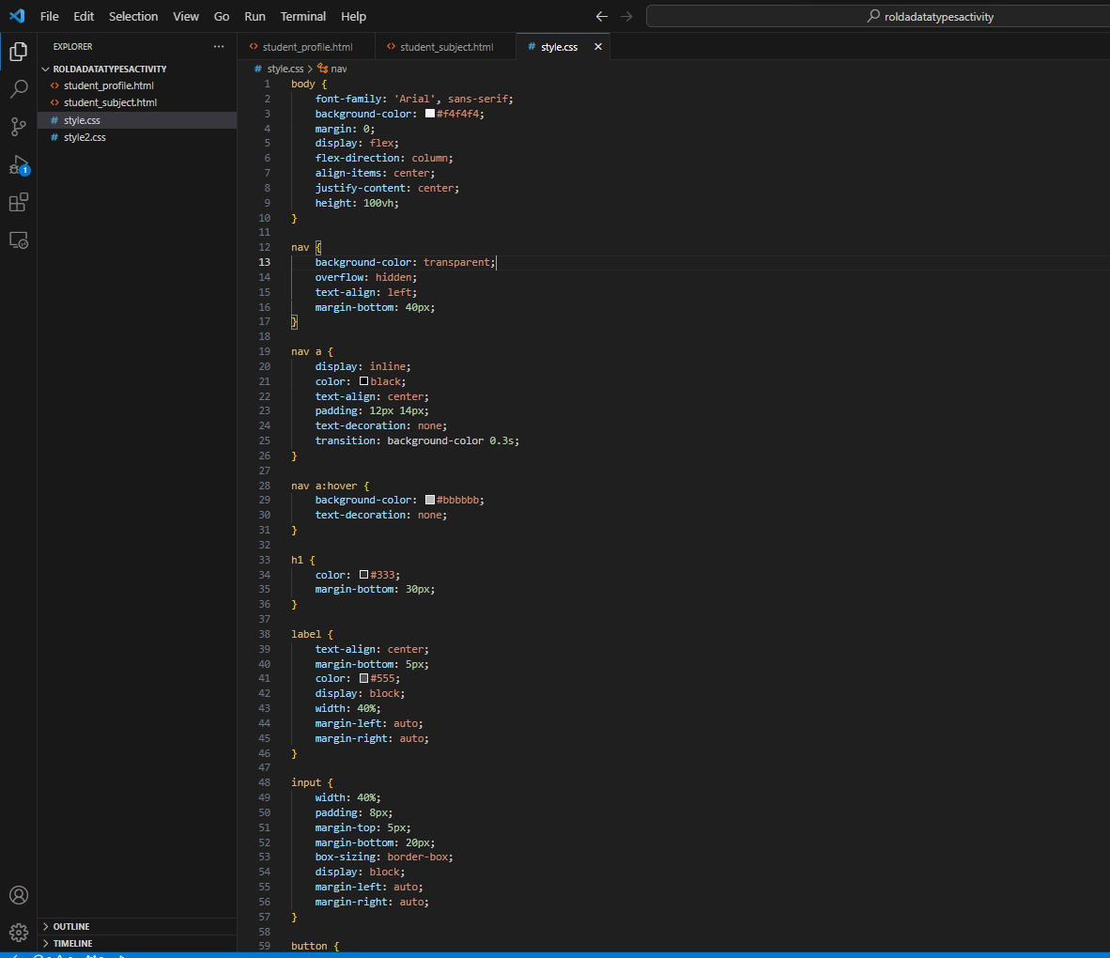

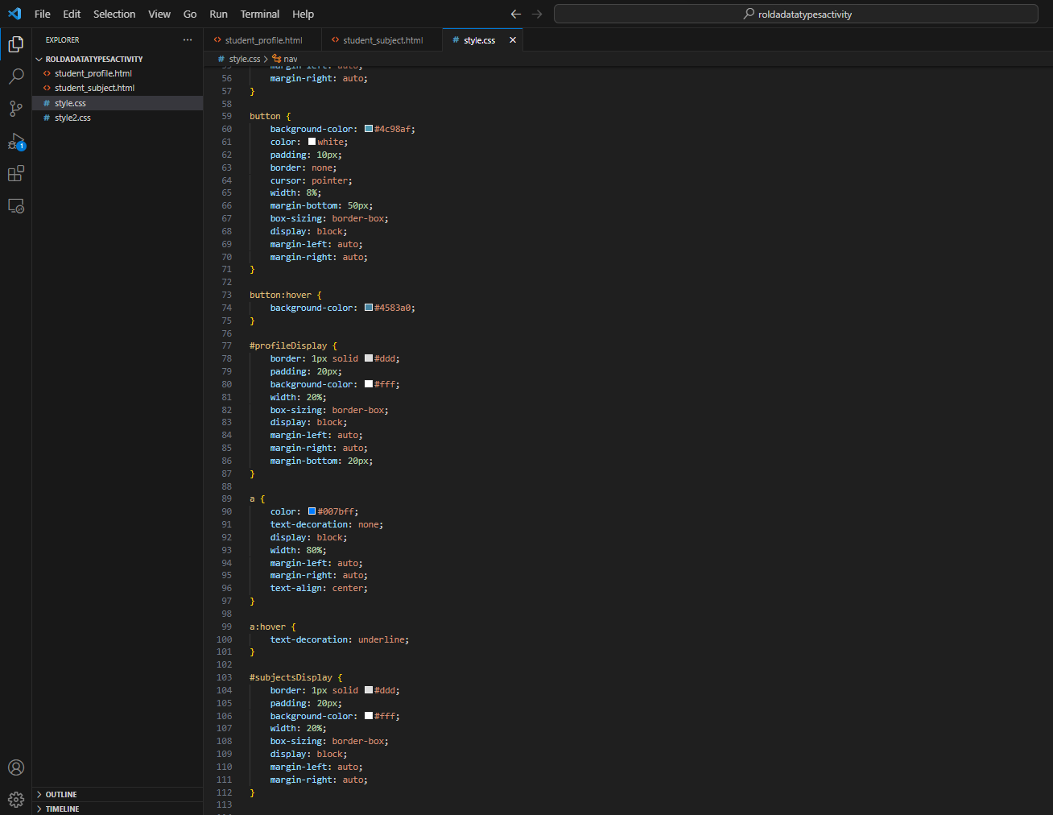

* **Output (student profile page):**

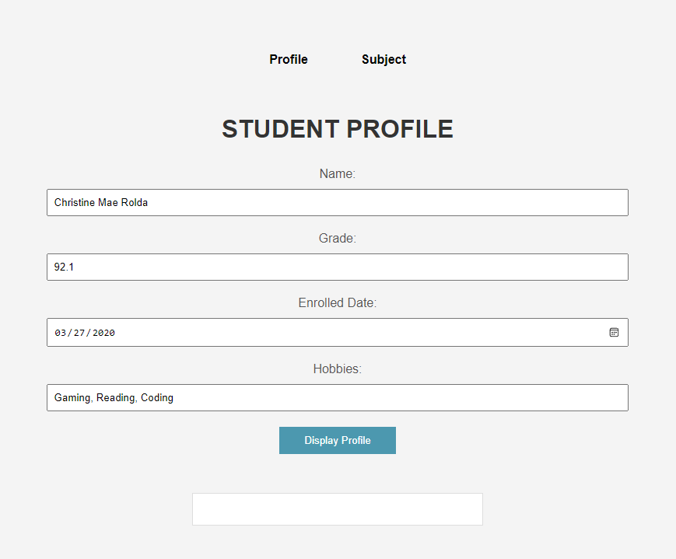

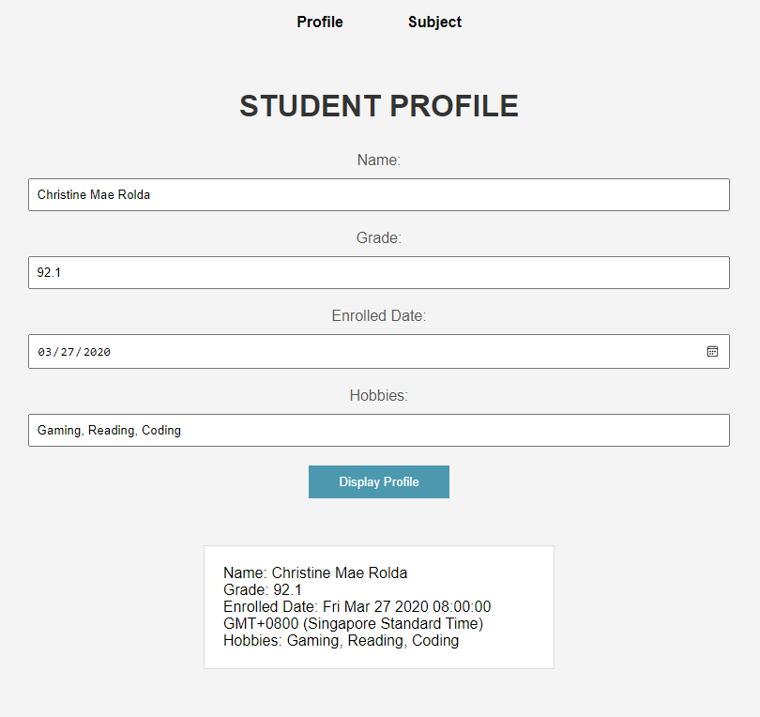

* **Output (student subject and professor page):**

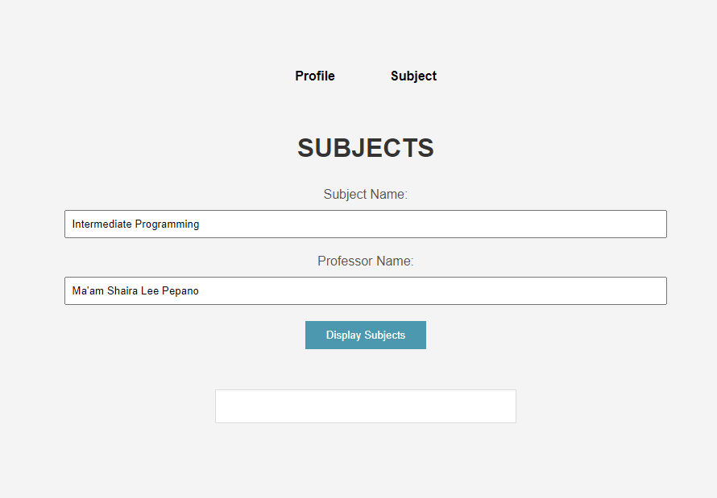

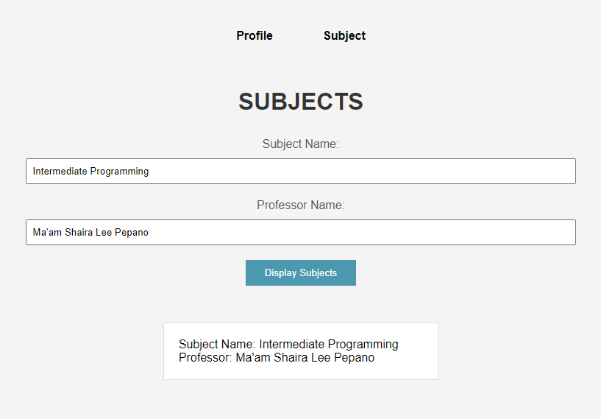

**FILE AND FOLDERS UPLOADED TO GITHUB:**

**Link:** https://github.com/OmnimvO/datatypes_rolda.git

**ALL SOURCE CODES FOR STUDENT PROFILE PAGE:**

* **Source Code (student_profile.html):**

<!DOCTYPE html>

<html lang="en">

<head>

<meta charset="UTF-8">

<meta name="viewport" content="width=device-width, initial-scale=1.0">

<title>Student Profile</title>

<link rel="stylesheet" href="style.css" class="style">

</head>

<body>

<nav>

<a href="student_profile.html"><b>Profile</b></a> &nbsp; &nbsp; &nbsp; &nbsp;

<a href="student_subject.html"><b>Subject</b></a>

</nav>

<script>

function displayProfile() {

var name = document.getElementById("name").value;

var grade = parseFloat(document.getElementById("grade").value);

var enrolledDate = new Date(document.getElementById("enrolledDate").value);

var hobbies = document.getElementById("hobbies").value;

var hobbiesArray = hobbies.split(',');

var profileText = "Name: " + name + "<br>Grade: " + grade + "<br>Enrolled Date: " + enrolledDate + "<br>Hobbies: " + hobbies;

document.getElementById("profileDisplay").innerHTML = profileText;

}

</script>

<h1>STUDENT PROFILE</h1>

<label for="name">Name:</label>

<input type="text" id="name" placeholder="Enter your name">

<label for="grade">Grade:</label>

<input type="text" id="grade" placeholder="Enter your grade">

<label for="enrolledDate">Enrolled Date:</label>

<input type="date" id="enrolledDate">

<label for="hobbies">Hobbies:</label>

<input type="text" id="hobbies" placeholder="Enter your hobbies">

<button onclick="displayProfile()">Display Profile</button>

<div id="profileDisplay"></div>

</body>

</html>

* **Source Code (student_subject.html):**

<!DOCTYPE html>

<html lang="en">

<head>

<meta charset="UTF-8">

<meta name="viewport" content="width=device-width, initial-scale=1.0">

<title>Subjects</title>

<link rel="stylesheet" href="style.css" class="style">

</head>

<body>

<nav>

<a href="student_profile.html"><b>Profile</b></a> &nbsp; &nbsp; &nbsp; &nbsp;

<a href="student_subject.html"><b>Subject</b></a>

</nav>

<script>

function displaySubjects() {

var subjectName = document.getElementById("subjectName").value;

var professor = { name: document.getElementById("professorName").value};

var subjectsText = "Subject Name: " + subjectName + "<br>Professor: " + professor.name;

document.getElementById("subjectsDisplay").innerHTML = subjectsText;

}

</script>

<h1>SUBJECTS</h1>

<label for="subjectName">Subject Name:</label>

<input type="text" id="subjectName" placeholder="Enter subject name">

<label for="professorName">Professor Name:</label>

<input type="text" id="professorName" placeholder="Enter professor name">

<button onclick="displaySubjects()">Display Subjects</button>

<div id="subjectsDisplay"></div>

</body>

</html>

* **Source Code (style.css):**

body {

font-family: 'Arial', sans-serif;

background-color: #f4f4f4;

margin: 0;

display: flex;

flex-direction: column;

align-items: center;

justify-content: center;

height: 100vh;

}

nav {

background-color: transparent;

overflow: hidden;

text-align: left;

margin-bottom: 40px;

}

nav a {

display: inline;

color: black;

text-align: center;

padding: 12px 14px;

text-decoration: none;

transition: background-color 0.3s;

}

nav a:hover {

background-color: #bbbbbb;

text-decoration: none;

}

h1 {

color: #333;

margin-bottom: 30px;

}

label {

text-align: center;

margin-bottom: 5px;

color: #555;

display: block;

width: 40%;

margin-left: auto;

margin-right: auto;

}

input {

width: 40%;

padding: 8px;

margin-top: 5px;

margin-bottom: 20px;

box-sizing: border-box;

display: block;

margin-left: auto;

margin-right: auto;

}

button {

background-color: #4c98af;

color: white;

padding: 10px;

border: none;

cursor: pointer;

width: 8%;

margin-bottom: 50px;

box-sizing: border-box;

display: block;

margin-left: auto;

margin-right: auto;

}

button:hover {

background-color: #4583a0;

}

#profileDisplay {

border: 1px solid #ddd;

padding: 20px;

background-color: #fff;

width: 20%;

box-sizing: border-box;

display: block;

margin-left: auto;

margin-right: auto;

margin-bottom: 20px;

}

a {

color: #007bff;

text-decoration: none;

display: block;

width: 80%;

margin-left: auto;

margin-right: auto;

text-align: center;

}

a:hover {

text-decoration: underline;

}

#subjectsDisplay {

border: 1px solid #ddd;

padding: 20px;

background-color: #fff;

width: 20%;

box-sizing: border-box;

display: block;

margin-left: auto;

margin-right: auto;

}